FALL 2024  
MEC325: INTRODUCTION TO ENGINEERING DESIGN  
DESIGN PROJECT  
**MILESTONE REPORT 1**



Assistive Transport of Children

when Walking

TEAM 1305

# team declaration

We, the undersigned members of Team SSNN in MEC325, agree that all team members have abided by all Ryerson Policies and course rules.

We furthermore accept that any violation of Ryerson Policy or course rules will lead to a grade penalty or charges of academic misconduct.

| STUDENT NAME | STUDENT NUMBER[1] |
| --- | --- |
| Andrej Draskovic | 32844 |
| Osama Noureddin | 46598 |
| Khiem Nguyen | 13735 |
| Osman Asif | 35477 |
| Codin Nguyen | 37911 |
| Yee Yin Kwok | 51256 |

# 

# Executive Summary

Strollers were designed as an assistive for infants and children, to carry them and any supplies for them. They are needed when caring for a child especially when you are going on a trip or outing. We are currently seeking to redesign and improve upon existing strollers such that it can be used by a wide range of people whilst being lightweight, compact, affordable, durable, whilst being environmentally conscious. (See [Design Brief](https://docs.google.com/document/u/0/d/1m8Y97Fyu418LrBMM7_kaH58dcY6xXEpoC8NbKqFQzBs/edit) for more information)

In order to achieve this we have decided to use aluminum for its lightweight, durable and corrosion resistant properties so that the stroller can be passed down and used for many years. Polyester was chosen for the exterior of the carriage as it is water resistant and durable allowing for better protection against the element, whilst the inside of the carriage is made from wool to help decrease the potential discomfort that pollyest may cause. (See [SKB Build Materials](https://docs.google.com/document/u/4/d/1YEjEXJfWXH6WhaKF20ACS39N4-rEMIp-a03EXtmuQ7s/edit) for more information)

A transforming design carriage was chosen as it would allow for a larger variety of users. The transforming carriage would allow a range of users from infant to child (roughly 3 months - 5 years of age) and allow for the stroller to be used for a longer period of time without needing to buy a new one if the infant grows out of the current one. (See [PDS](https://docs.google.com/document/d/19KGi0PIx9DB-yrT7nRob-Qy8iMO80u0HPKYj3moV8S4/edit) for more information)

As many families use a car to get around, a folding design was chosen as it would allow for the stroller to be more space efficient. The proposed folding stroller would allow for the stroller to be stored in the trunk of a car allowing the stroller to be more portable. This allows for families to bring this stroller on trips without needing to worry too much about whether or not there is enough space. (See [PDS](https://docs.google.com/document/d/19KGi0PIx9DB-yrT7nRob-Qy8iMO80u0HPKYj3moV8S4/edit) for more information)

A 5th retractable wheel was added to the design stroller such that a variety of different can be accessed. By adding a 5th retractable wheel, it allows the stroller to go from 4 wheels (2 swivel, 2 fixed) to 3 wheels (3 swivel) which allows for the stroller to move omni directionally. Which allows the user to move into tight spaces without turning and lets the user turn with minimal space. (See [PDS](https://docs.google.com/document/d/19KGi0PIx9DB-yrT7nRob-Qy8iMO80u0HPKYj3moV8S4/edit) and [SKB Stroller Wheels](https://docs.google.com/document/u/4/d/1YEjEXJfWXH6WhaKF20ACS39N4-rEMIp-a03EXtmuQ7s/edit) for more information)

# Design Brief Summary

The design brief concerns the creation of Assistive Transport for Children when Walking, or in strollers ([Design Brief](https://docs.google.com/document/u/0/d/1m8Y97Fyu418LrBMM7_kaH58dcY6xXEpoC8NbKqFQzBs/edit)). The objective is to design a human-powered vehicle for newborn to toddler-aged children. This includes both strollers and baby carriages.

Strollers provide a safe way for caregivers to transport their children and be with them while allowing mobility. While they differ in cost and quality, the same basic needs all need to be met. These include the comfort of caregiver and child, storage solutions, ease of use, and affordability, to name a few. The inclusion of many different users is also a necessity, as is storage.

A NGO came forward with a request for a design proposal for a stroller. They had many concerns about accessibility, sustainability, and comfort. Ultimately, our team these aspects most important:

* Include more people as users
* Ensure ethical and sustainable practices throughout lifecycle
* Usable by a single untrained person
* Remain safe in all real world use scenarios
* Account for Human Factors in all stages of use and lifecycle

The goal is to design a human-powered vehicle for newborn to toddler-aged children that enhances the usability, safety, and comfort of traditional strollers while accommodating a broad range of caregivers. This vehicle must be easy to operate by a single untrained user, addressing real-world challenges like public transit, hikes, and public spaces. It should be durable, affordable, and adaptable to the diverse needs of families, including multiple users such as siblings or grandparents. Prioritizing low environmental impact, safety, and ethical considerations throughout its life cycle, the design must also improve the comfort and dignity of both users and co-users ([SKB: Goals](https://docs.google.com/document/u/0/d/1YEjEXJfWXH6WhaKF20ACS39N4-rEMIp-a03EXtmuQ7s/edit)).

# 

# 

# Background

The project focuses on the design of a stroller intended for newborns to toddlers, ensuring usability, safety, comfort, and adaptability to various environments. The design embeds positive features of the top competitors such as the UPPAbaby Vista V2, while eliminating negative aspects of the competition, particularly related to sustainability and ergonomic fit.

## **Target audience:**

1. Parents and Caregivers aged between 20-45 years.
2. Consideration of Users with Different Abilities.
3. Focus on the ease of use for both caregiver and child.

## **Key Design Goals:**

1. Versatility for various terrains, from urban streets to off-road ones: beach, hiking trail.
2. Modular design capable of growing with the child by easily converting from a newborn bassinet into a toddler seat.
3. Sustainability and eco-friendliness as core principles.

## **Features of child comforts include:**

1. Flat seat surface for promoting the proper development of posture.
2. An adjustable footrest for the child to extend their leg as they grow up.
3. Weather-resistant materials create comfort in all seasons.

## **Caregiver Ergonomics:**

1. These handlebars are adjustable for the different heights of caregivers.
2. The light frame of recycled aluminum makes it easy to maneuver.
3. Integrated storage to lower the center of gravity for improved stability.

## **Wheels Design:**

1. Fixed and swivel mechanisms can be combined:
   1. Provides stability on rough terrain.
   2. Allows for easy maneuverability when working in tight spaces.
2. Air Chamber wheels:
   1. Low maintenance.
   2. Puncture-proof: for bump-free travel over any surface

## **Sustainability Efforts:**

1. Use of Environmentally Friendly Materials:
   1. Recycled aluminum for the frame.
   2. Mycelium-based biodegradable packaging.
2. Long product lifecycle to minimize environmental impact.
   1. Emphasized the durability that will reduce the frequency of replacement.

## **Modularity and Expandability:**

1. Stroller grows with the child: Newborn bassinets convert to toddler seating.
2. Can accommodate more babies without having to get another stroller.

# 

# 

# Requirements

Stroller design goes far beyond placing wheels under any old seat. It requires deep insight into both caregiver and child needs, with an absolute need to follow precise standards that address the issues of safety and ergonomics. Our stroller design strikes a balance among comfort, usability, and safety; therefore, it may be highly appropriate for diverse settings and caregiving situations. Duly recognizing that comprehensive research served as the backbone for much of our design, we have tried to address the needs of both the physical and emotional needs of caregivers and children alike within the context of recognized standards and guidelines such as ASTM F833-21.

## **Comfort and Usability for the Caregiver**

Understanding the diverse physical capabilities of caregivers was a priority in our design process. Our stroller includes adjustable handlebars and footrests; thus, caregivers of different heights can push it comfortably with minimum strain on the back, wrist, and shoulder muscles (SKB 4.6). While extended use of a stroller can be uncomfortable if not properly adjusted to the user's body, customizable features surely make it an ergonomic experience that prevents repetitive strain injuries. Adjustable components, accordingly, have been found with research evidence to be associated with considerable improvements in user comfort, which manages caregiving with much more ease and less burden.

On the other hand, the lightweight design makes the weight of our stroller not exceed 30 lbs (SKB 4.4) This lightweight framework ensures that caregivers with any level of physical strength can manage the stroller with ease, maneuvering through crowded public transportation or lifting it into the trunk of any car. The lightweight frame of the stroller does not compromise on durability: it achieves the right balance between light handling and solid robustness, ensuring reliable performance day by day without ingredients of unnecessary strain for the caregivers.

## 

## **Child Comfort and Safety**

Equally important, too, is the comfort and safety of the child. Our stroller has a fully reclining seat that extends to a 180-degree angle, a very fundamental consideration for infants and young children who need good support when they are resting. It is for this reason that, according to pediatric ergonomic dictates, newborns must be kept in a recline position to keep their spines correctly aligned during nap times. Moreover, the adjustability of the seat means it can be used from infancy to toddler years, accommodating the child's growth while sacrificing neither comfort nor posture. Apart from the reclining seat, the stroller further provides for adjustable seating heights. Such a feature will ensure the longevity of the stroller in the sense that as the child gets older, his or her use of it will remain comfortable and supportive during use. The long-term adaptability of such a device extends its functionality over many years, making it economically viable as well as functionally credible to the caregiver for accommodating a wide age bracket without any supplementary innovation to the device, therefore giving it more credibility (SKB 2.1).

Performance on different terrains In our design, the suspension system of the stroller also represents an important part of providing smooth comfort during rides on various types of terrain, from urban pavement to more rugged and uneven surfaces (SKB 2.2). The shock-absorbing suspension reduces the effect of a jolting bump, further comforting the child. Whether maneuvering the stroller through the busy city environment or onto rougher outdoor trails, the suspension system ensures a smooth, comfortable ride from the child's perspective while providing the caregiver with increased control and maneuverability. This feature will help solve the dual need for the comfort of the child and ease of use by the caregiver to ensure the stroller is versatile enough for whatever environment it is being used in.

## **Human Factor Considerations**

The table below summarizes how key human factors have influenced our design decisions, with an emphasis on features that improve the experience for both caregivers and children:

| **Human Factor Consideration** | **Design Feature** | **Benefit** |
| --- | --- | --- |
| Varying caregiver heights | Adjustable handlebars | Reduces back, wrist, and shoulder strain (SKB 4.6) |
| Varying caregiver strength levels | Lightweight design (<30 lbs) | Easier lifting and maneuvering, especially in public spaces (SKB 4.4) |
| Child spinal support | Full 180-degree reclining seat | Promotes healthy posture and spinal development (SKB 2.1) |
| Comfort on uneven terrain | Shock-absorbing suspension system | Ensures smooth ride across various environments (SKB 2.2) |
| Long-term usability as the child grows | Adjustable seating height | Accommodates growth without compromising comfort (SKB 2.1) |

The following table identifies practical applications of our design features to illustrate how they investigate major human factors and considerations to enhance the experience and make the overall user experience in a manner consonant with the SKB standards:

## **Compactness and Portability**

Another important feature of our design is its compactness. When folded, the stroller utilizes less than 9 cubic feet of space, making it perfect for urban caregivers who many times have to store it in a small car trunk or apartment closet. This does not compromise its structural integrity and functionality.

Also, its foldable small size makes it easy to carry in public transport systems, enabling caretakers who live in densely populated areas to maneuver their way with ease through daily routines.

It is small, and compact, yet without compromising on much-needed features. It contains storage space for whatever one may need with the child, be it diapers, bottles, or one's items to ensure that the caregiver can reach everything they might need. In this way, a balance between portability and functionality creates a versatile stroller that will grow and adapt to a wide range of caregiving environments.

## **Safety and Durability**

Safety is a priority across every aspect of our design. This means that it follows the ASTM F833-21 guidelines for children, ensuring that it meets very stringent standards in such things as frame stability, the strength of the wheels, and lock efficacy. There is a 5-point harness system so the child remains in place, even when the stroller is fully reclined upright.

The frame was tested for strength and durability by repeated uses while maintaining its structural integrity over time (SKB 5.5). Moreover, it has a canopy on the stroller that is UPF 40+, which is very important to protect the child from the ultraviolet rays of the sun. It is considerable for walks because both the child and the caregiver may suffer from sun exposure. The canopy will guarantee the child's safety during long walks in the street to prevent sunburn or heat stroke.

## **Real-World Usability and Feedback**

This design was heavily influenced by extensive real-world usability testing and caregiver feedback. We tested the features that mattered most to them in terms of ease of use, comfort, and safety. By using principles of ergonomics in this design, we developed an instinctive stroller for use, adaptable to the different needs of caregivers, and supportive of child development.

Whether for running quick errands, taking a longer walk, or commuting through the day, the thoughtful features of this stroller make it practical and versatile for the modern caregiver.

The design also incorporated the HF Quick Scan, which evaluated the stroller's aptitude to provide both physical and emotional support for the child (SKB 4.6). This tool led us to understand that our design allows smooth and comfortable operation, whether uphill or down, and also takes into consideration the comfort and security of the child in every situation.

## **Conclusion**

Our extensive ergonomic research, real-life feedback, and strict adherence to the standards of safety all combine in the design of this stroller to produce a product that can meet the diverse needs of today's caregivers. Lightweight and compact, it is designed with ease of use in mind. However, adjustable features and strong suspension systems are bound to provide maximum comfort for both the caregiver and the child. Every design decision reflects a deep-seated commitment to safety, usability, and longevity, and our stroller can be depended upon in a myriad of caregiving environments. Equipped with handy features like adjustable handlebars, shock-absorbing suspension, and the ability to recline this seat fully for 180 degrees, our stroller does more than just pass the certification criteria laid down by recognized standards; instead, it promises to be among the best options available for both caregivers and children.

# 

# 

# 

# 

# 

# 

# 

# 

# Design concepts

# **Design Concept 1.**

Osman Asif’s Design concept

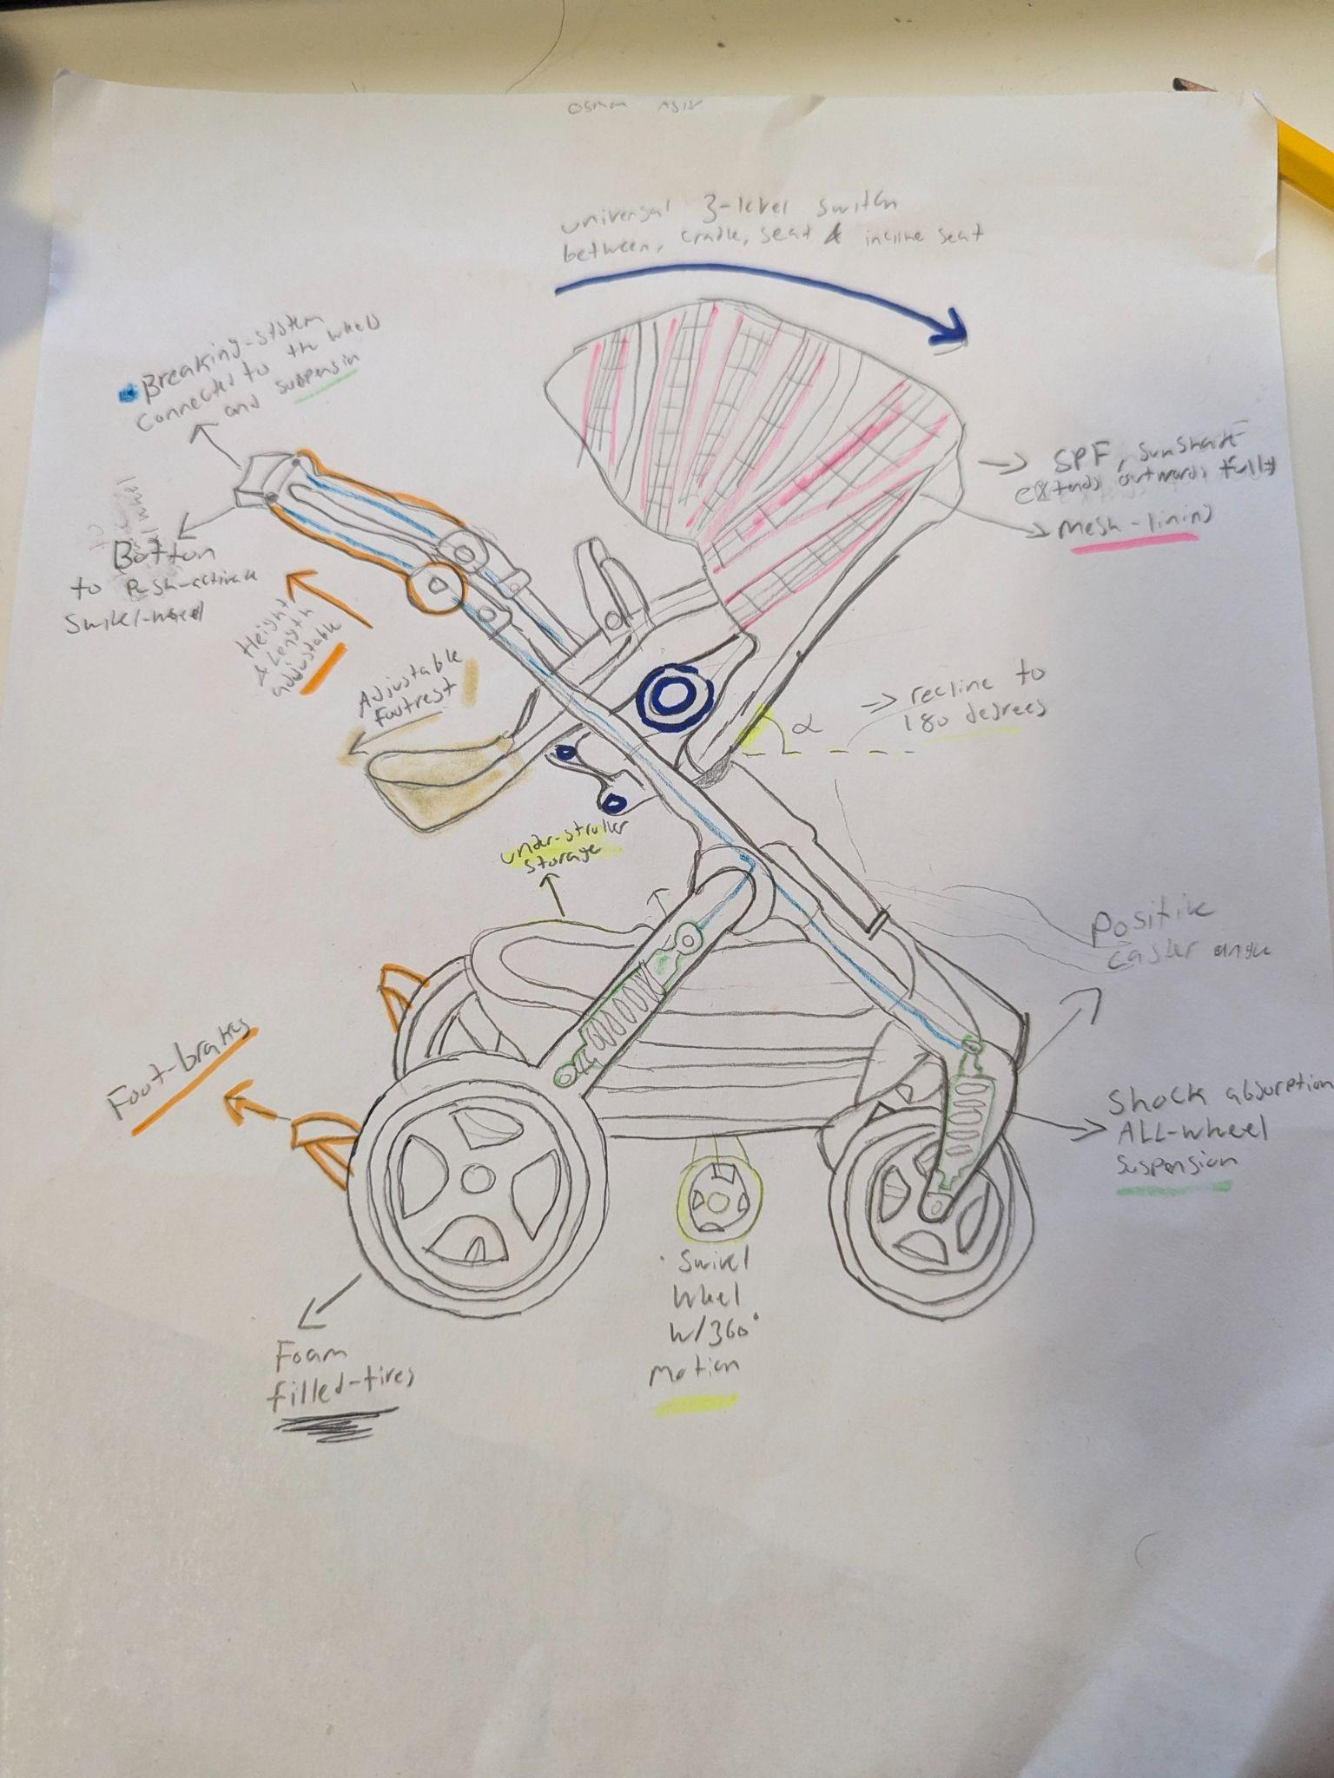

**Description**

The design shows a four-wheel stroller that has the ability to recline to a full 180 (highlighted angle) degrees to allow the seat to transform from a seat to a cradle (dark blue) while providing the maximum amount of comfortability for both the child and the parent. It can also change from facing towards the parent to facing away, given the modular seat design. Furthermore it allows for more versatility when dealing with a growing child, making it a universal stroller that is not in need of replacing by incorporating a height adjustable seat to allow for even more customization, an adjustable footrest is also included that ensures the safety of the child by not allowing any dangling feat and a comfortable resting position that promotes a positive pelvic position. Furthermore, the adjustable handlebar (orange) allows for the parent to comfortably push the stroller with a neutral wrist position. The mesh-lined sunshade(pink) prevents harmful UV rays from constantly shining on the child and allows for proper ventilation through the mesh lining and can fully encase the seat in order to protect the child from any harmful weather conditions. The foot brake system allows for long stops when the stroller is not in motion and is rather parked. The push-activated brake connected to the wheels & suspension system(green) through a brake line (blue line) that is incorporated into the frame, allowing for sudden, but safe stops when needed. Furthermore the four-wheel system incorporates foam-filled tires that along with the suspension system create an enjoyable and comfortable ride by reducing the shock and vibrations that can be experienced. Moreover, through the use of the brake system, pushing down further can release the swivel wheel that can allow for maneuverability in tight spaces and when sharp turns are involved.

**Usage scenario**

Setup

1. Easily unfold the stroller due to the 3-way locking mechanism
2. Adjust the handlebars to align with the waist
3. Adjust the footrest and seat height for the child
4. Add items to the under-stroller storage
5. Adjust the modular seat to face away from the stroller or towards

Use

1. Place the child into the stroller while also Adjusting the recline angle to accommodate the child
2. Make sure the stroller strap is secured and tightened
3. Adjust the mesh-line sunshade to reduce the amount of sunshine
4. Push the stroller, the suspension system absorbs any shocks or vibrations
5. Immediate stops can occur with the push-activated stroller breaks on the handle
6. Permanent stops can occur with the foot-brakes
7. The swivel wheel can be activated with the push-brake to accommodate maneuverability in tight spaces
8. Use the under-stroller storage space to place any essential items

Put away

1. Make sure the child is out of the seat, while also ensuring the adjustable seat is locked in a fixed position so that it won’t move
2. Make sure that the foot brake is engaged and the swivel wheel is disengaged
3. Lock in the seat at a 60 degree angle(position found in the design), Starting by removing the storage
4. Release all three locks of the seat and push downwards
5. fold the stroller
6. Store the stroller

| Demand Type | US Step # (Most demanding task) | Demand Level | Notes |
| --- | --- | --- | --- |
|  | **SET UP** |  |  |
| Perceptual | 1a | 2 | 3-way locking system requires awareness and touch |
| Cognitive | 1c | 2 | Requires thought about the comfortability of the child especially as they grow |
| Physical | 1e | 3 | Requires physical force in order to move the seat to face the other direction |
|  | **USE** |  |  |
| Perceptual | 2c | 1 | Requires perception on how much sun is being shined on the child, and how much to extend out the shade |
| Cognitive | 2g | 3 | Requires a unique solution to maneuverability in tight spaces, yet something uncommon, so it requires decision making on when to use |
| Physical | 2d | 2 | The suspension and foam filled wheels allow for a smoother ride however to push the stroller is still physically demanding |
|  | **PUT AWAY** |  |  |
| Perceptual | 3c | 2 | Use of vision to ensure the seat is angled properly and locked in place |
| Cognitive | 3d | 3 | Needs careful coordination to unlock all 3 mechanisms and to fold in the right sequence. |
| Physical | 3e | 2 | Somewhat physically demanding to place the stroller in a storage area |

# 

# 

# 

# 

# 

# 

# **Design Concept 2.**

Osama Noureddin’s Design Concept

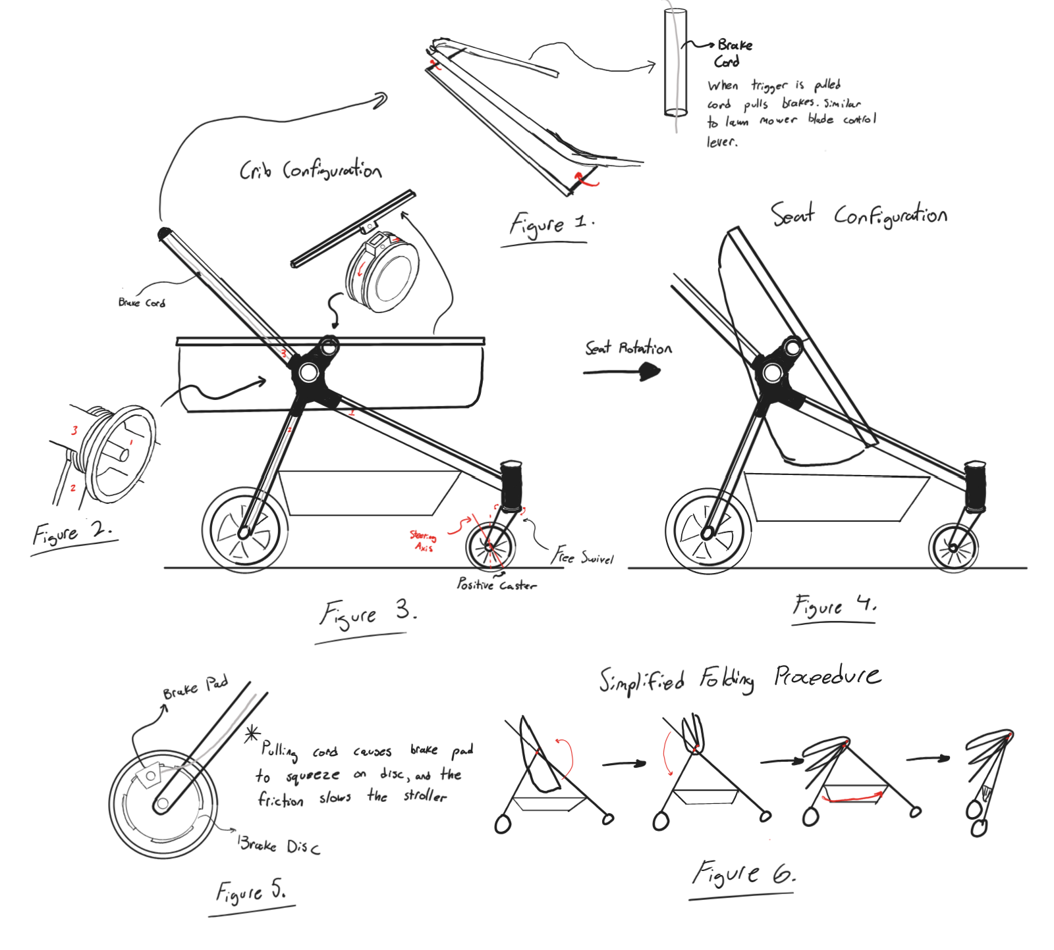

**Description:**

The design concept sketch illustrates a four-wheel stroller design that integrates various features, most prominently a transformable seat that goes from a crib to seat, as seen in *Figure 3 and 4*. This allows the stroller to last multiple years as the child grows older, without the need for an additional stroller to be purchased. Also featured on the stroller is a storage compartment underneath the seat, which would be made entirely of fabric and be attached to a rod connecting the left and right side of the frames. The fabric would allow for changing of shape when folding. The stroller also features a folding mechanism for storage that works through two points of rotation as shown, one for the seat/crib and one for the chassis and handlebars. A visualization of the folding procedure can be seen in *Figure 6*. The two front wheels of the stroller are swivel wheels with positive caster (see [SKB 5.5](https://docs.google.com/document/d/1YEjEXJfWXH6WhaKF20ACS39N4-rEMIp-a03EXtmuQ7s/edit) for wheel caster), while the two rear wheels are fixed. Also not clearly shown in the sketch are the seatbelts, which serve an important purpose in keeping the infant from falling out of the stroller and are an essential safety feature. Lastly, the rear wheels also feature an active braking system, that is activated via a brake cord similar to that on a bicycle that runs through the hollow chassis. The brakes are activated through a squeezable bar on the handle, which takes inspiration from the blade control levers found on many gas-powered lawn mowers.

**Usage Scenario:**

1. Setup
   1. Unfold the stroller by unlocking the chassis lock and rotating the seat/crib and handlebar into position as shown in Figure 6.
   2. Ensure that the seat/crib is properly configured based on the child's age.
   3. Secure the brake cord by checking the handlebar level is properly in place and working to engage/disengage the brakes.
2. Use
   1. Place the child securely in the seat or crib, adjusting the seat as needed.
   2. Ensure that the seat belts are securely fastened around the child.
   3. Begin pushing the stroller.
   4. If you need to slow down or stop, pull on the brake handle to engage the bake cord mechanism.
   5. Utilize the fabric storage compartment underneath for carrying personal items, ensuring it doesn’t interfere with stroller operations.
3. Put-Away
   1. Ensure the child is out of the seat/crib and is at a safe distance, and ensure there are no items left in the storage compartment.
   2. Fold the stroller by first collapsing the seat/crib and handlebar using the folding procedure outlined in Figure 6.
   3. Lock the chassis into the folded position for easy storage or transport.
   4. Store the stroller in an appropriate place, ensuring it is secure and out of the way.

| Demand Type | US Step # (Most demanding task) | Demand Level | Notes |
| --- | --- | --- | --- |
|  | **SET UP** |  |  |
| Perceptual | 1c | 2 | Use of touch and vision to ensure seat is locked in place for safety |
| Cognitive | 1b | 1 | Familiarity with how brakes feel |
| Physical | 1a | 3 | Heavy lifting with two hands for support and back bending needed |
|  | **USE** |  |  |
| Perceptual | 2d | 3 | Good spatial awareness and eyesight needed |
| Cognitive | 2d | 3 | Good hand-eye coordination and quick reaction time needed to quickly grab brake bar |
| Physical | 2c | 2 | Strong push may be required depending on weight of infant and storage items |
|  | **PUT AWAY** |  |  |
| Perceptual | 3a | 3 | Awareness of surroundings sense of touch for unlocking safety features |
| Cognitive | 3b | 2 | Ability to understand steps in correct order to fold efficiently |
| Physical | 3c | 2 | Good physical control over the stroller with both hands needed |

# 

# 

# 

# 

# 

# 

# 

# 

# **Design Concept 3.**

Codin Nguyen’s Design Concept

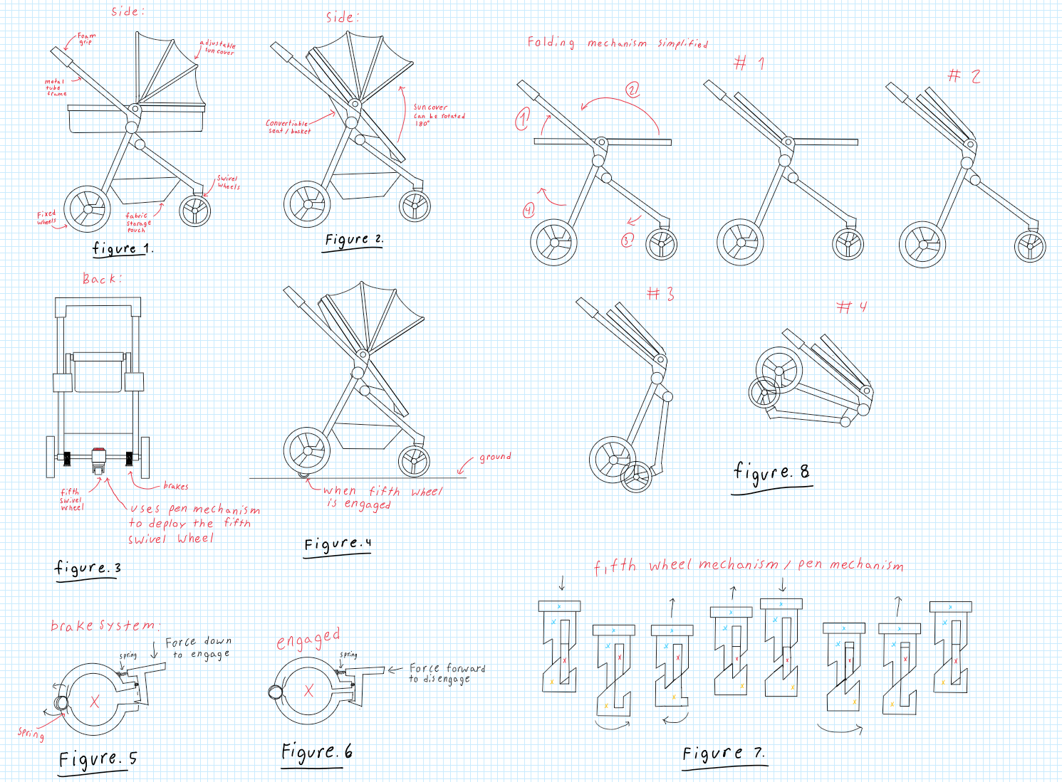

**Description:**

The design concept sketch presents a five-wheel stroller featuring several innovative elements, most notably a transformable seat that shifts from a basket to a stroller seat with a 40-degree incline (see Figures 1 and 2). This versatility allows the stroller to accommodate a growing child over multiple years, eliminating the need for a new stroller. A standout feature is the deployable fifth swivel wheel, activated by stepping on a red button. When engaged, this fifth wheel supports the stroller on its two front swivel wheels and a single rear swivel wheel, facilitating omni-directional movement, which is particularly beneficial in confined spaces like public transport (see Figure 4). To retract the fifth wheel, users can press the red button again, causing it to retract smoothly like a pen. When the fifth wheel is disengaged, the stroller moves on two front swivel wheels with positive caster (see SKB 5.5 for caster specifications), while the two rear wheels remain fixed. The design also includes a braking system, activated by applying force as demonstrated in Figures 5 and 6, allowing users to lock the stroller in place—an essential feature for safety on public transport or inclined surfaces. The stroller incorporates a folding mechanism for easy storage and transport. Additionally, a seatbelt is integrated for child safety, preventing toddlers from falling out while the stroller is in motion.

**Usage Scenario:**

1. Setup
   1. Unfold the stroller as shown in figure 8.
   2. Ensure that the seat/basket is properly configured based on the child's age.
2. Use
   1. Place the child securely in the seat or crib, adjusting the seat as needed.
   2. Ensure that the seat belts are securely fastened around the child.
   3. Disengage the stroller breaks shown in figure 5 and 6
   4. Begin pushing the stroller.
   5. Utilize the fabric storage compartment underneath for carrying personal items, ensuring it doesn’t interfere with stroller operations.
   6. To engage the omnidirectional mode step on the red button located between the two back wheels.
   7. To disengage the omnidirectional mode step on the red button located between the two back wheels.
3. Put-Away
   1. Ensure the child is out of the seat/crib and is at a safe distance, and ensure there are no items left in the storage compartment.
   2. Fold the stroller by first collapsing the seat/crib using the folding procedure outlined in Figure 8.
   3. Store the stroller in an appropriate place, ensuring it is secure and out of the way.

|  |  |  |  |
| --- | --- | --- | --- |
| Demand Type | US Step #  (Most demanding task) | Demand Level | Notes (including what drives the demand) |
|  | **SET UP** |  |  |
| Perceptual | 1a | 2 | Requires visual confirmation of correct unfolding |
| Cognitive | 1b | 3 | Proper sequence needed for assembly based on child's age |
| Physical | 1a | 3 | forceful bending and lifting movements needed; needs two handed manipulation |
|  | **USE** |  |  |
| Perceptual | 2b | 2 | Visual and tactile input needed to ensure correct belt fastening |
| Cognitive | 2f/g | 2 | User must recognize and understand the button for mode change |
| Physical | 2d | 3 | Requires continuous force application and maneuvering control, especially over uneven surfaces |
|  | **PUT AWAY** |  |  |
| Perceptual | 3b | 3 | Requires visual confirmation ensure no child or items remain inside |
| Cognitive | 3c | 2 | Understanding folding steps and sequence is needed |
| Physical | 3d | 3 | Requires strength to lift and position stroller securely |

# 

# 

# 

# 

# 

# 

# 

# 

# 

# **Design Concept 4.**

Andrej Draskovic’s Design Concept

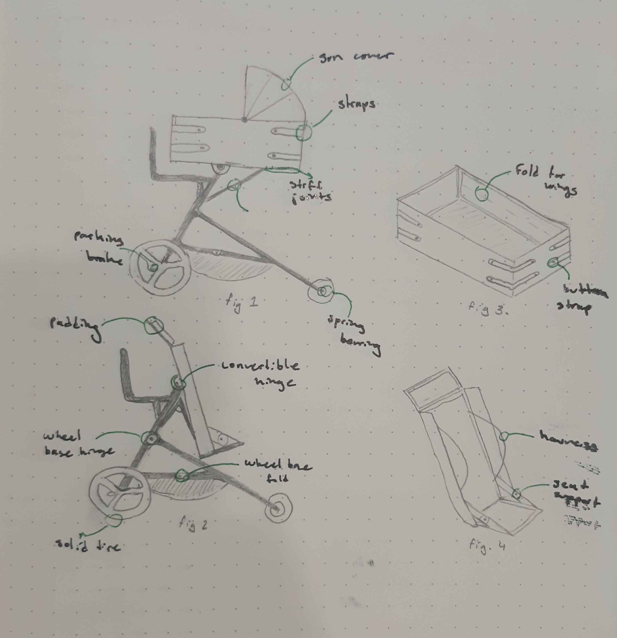

**Description**

Shown is a design concept for a stroller with the ability to convert to a baby carriage for younger children/infants. The primary objective of this design (and also the largest hurdle) is to create the convertible mechanism. This design uses a pin joint and hinge joint to tilt the carrier forward and create a seat (note fig. 2, transformation diagram). This complies with the regulations by having a cover and switch to engage joint motion, giving two distinct actions for folding. The seat is the second large change necessary for the conversion. In essence it is a rectangular prism with the ability to fold down all its sides. In carriage mode, the sides are folded and attached together, making a secure space for the infant to lie down in. The hinges for the sides are stiff, so while they are flexible it is not possible to move them without intentional effort. As well, the sides are connected with buttoned straps(two for each connection) further securing the position. The inside is padded and well connected. When converted, the sides open up into the seat position. The side wings fold in half, giving more space for seating while still giving protection on the sides.

Another large challenge was getting the stroller to fold for storage. This was done with two hinge joints between the front and rear legs. These joints also support the included storage. The wheelchair uses the pin joint in the center to fold flat. As well, two joints near the handles allow for the top part to fold down as well. The seat can go flat, allowing for access.

The wheelbase and wheels are designed to meet the maneuverability and functionality requirements. The rear wheels are on a fixed axle, and are large for good terrain movement. They also ride on spring bearings, giving a smoother ride. The front wheels are able to swivel freely, giving the stroller a very tight turning radius. Both sets come with solid tires, preventing the issue of punctures or leaks. They also have deep treads, giving better grip.

Materials used are all sustainable. The frame is made out of recycled aluminum, as it is both strong and light while being inexpensive. The seat and other fabric components are made out of replaceable spill-proof fabrics that are both durable and comfortable.

**Usage Scenario**

1. Setup
   1. Place folded stroller on ground wheels down
   2. Remove convertible hinge cover
   3. Press latch, and unfold the top half upright
   4. Continue holding the latch, unfold the wheelbase into its normal position
   5. Set seat to correct position, adjust as necessary
2. Use
   1. Place child in crib/seat
   2. Adjust restraints so the child is comfortable yet secured in place
   3. Adjust cover to liking
   4. Stand behind stroller, hold on to handlebar
   5. Disengage the foot parking brake, push
   6. Place items in the storage below
   7. Unfold/fold seat to meet needs
      1. Remove convertible hinge switch cover, press switch
      2. Tilt seat downwards from carriage position, making sure hinge joint is bending
      3. Unclasp each strap, storing them in provided pouch
      4. Fold side wings, bend sides to form headrest and seat
      5. Secure seat with straps
3. Put-away
   1. Remove child from seat
   2. Remove convertible hinge switch cover, depress switch
   3. Fold top half downwards, compress wheelbase
   4. Store stroller

| Demand Type | US Step #  (Most Demanding Task) | Demand Level | notes |
| --- | --- | --- | --- |
|  | **SET UP** |  |  |
| Perceptual | 1b - Remove convertible hinge lock cover | 2 | Requires vision and touch |
| Cognitive | 1e - Set seat to correct position | 3 | Sequence needed, remembering positions |
| Physical | 1d - Unfold wheelbase into normal position | 3 | Bending, some physical exertion |
|  | **USE** |  |  |
| Perceptual; | 2e - Disengage parking brake | 1 | Bright red, easy to see/feel |
| Cognitive | 2g - Unfold seat | 3 | Multiple steps, adjustment |
| Physical | 2f - Place items in storage | 2 | Bending, easy to reach though |
|  | **PUT AWAY** |  |  |
| Perceptual | 3b - Remove convertible cover, depress switch | 2 | Requires vision and touch |
| Cognitive | 3c - Fold top half downwards | 2 | Easy to do, requires 2 steps |
| Physical | 3d - Store stroller | 2 | Can require lifting |

# 

# 

# 

# 

# 

# 

# 

# **Design Concept 5**

Khiem Nguyen’s Design Concept

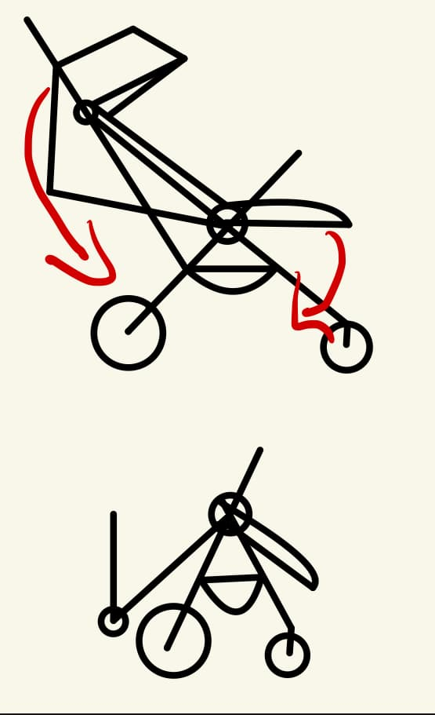

**Description**

This design of the stroller focuses on multi-functional versatility combined with eco-friendly materials, enabling it to grow with a child from an infant to a toddler. It features a convertible seat that converts between two modes for easy transformation from a baby carriage for infants to a toddler seat for long-term use. The frame features recycled aluminum, combining durability with lightweight handling. The Stroller uses an advanced one-hand fold mechanism for easy storage. The smart brake lets it stop with maximum safety through hand- and foot-operated systems. The wheels are adapted to different terrains because of the big wheels in the back for added stability and 360-degree swiveling wheels in the front for tight maneuverability. Under-seat expandable storage for different storage needs with detachable compartments for added convenience is designed within this stroller.

## **Usage Scenario**

### Setup:

1. Place the stroller on the ground with the wheels down.
2. Unlock the chassis and unfold the seat to the desired position (cradle or toddler seat).
3. Adjust the handlebar to suit the user’s height.
4. Engage the smart brake system for safety checks before use.
5. Use the one-hand fold mechanism if storing the stroller after setup.

### Use:

1. Place the child securely into the convertible seat.
2. Adjust the seat to fit the child’s size, ensuring seatbelts are fastened properly.
3. Push the stroller with ease, even on uneven surfaces, as the terrain-adaptive wheels provide stability and maneuverability.
4. Use the under-seat storage to carry essential items, detaching compartments as needed for convenience.
5. Utilize the smart brake system with either hand or foot to stop the stroller when necessary.

Put Away:

1. Remove the child and items from the seat and under-seat storage.
2. Engage the foot brake to keep the stroller stationary.
3. Press the folding button on the handlebar and gently push down.
4. The front of the stroller will collapse, with the seat and front wheels folding inward.
5. Move to the middle of the stroller to continue pushing down as the handlebar and frame fold inward.
6. Secure the folded stroller by engaging the locking latch if available.
7. Store the stroller in a secure place, ensuring it's locked and compact.

### Product Use Demands Analysis Table

| **Demand Type** | **US Step # (Most demanding task)** | **Demand Level** | **Notes (including what drives the demand)** |
| --- | --- | --- | --- |
| **SET UP** |  |  |  |
| Perceptual | 2 – Unfolding the seat into the correct position | 2 | Requires vision and touch to adjust the seat into the cradle or toddler mode. |
| Cognitive | 3 – Adjusting the handlebar to match user’s height | 1 | Requires understanding of how to adjust the handlebar for ergonomic use. |
| Physical | 1 – Placing the stroller on the ground and unfolding | 2 | Some physical exertion is needed to unfold and position the stroller properly. |
| **USE** |  |  |  |
| Perceptual | 2 – Adjusting seatbelt and seat for child safety | 2 | Visual confirmation and tactile input are required to secure the child. |
| Cognitive | 5 – Using the smart brake system during operation | 2 | Requires decision-making and coordination for stopping the stroller safely. |
| Physical | 3 – Pushing the stroller over uneven terrain | 2 | Terrain-adaptive wheels ease the task, but pushing over rough ground requires some force. |
| **PUT AWAY** |  |  |  |
| Perceptual | 1 – Ensuring the child and items are removed | 2 | Visual check to confirm nothing is left in the seat or storage. |
| Cognitive | 2 – Folding the stroller using the one-hand fold mechanism | 2 | Following the correct sequence for folding the stroller is necessary. |
| Physical | 3 – Storing the stroller | 2 | Light physical effort is required to fold and store the stroller. |

# 

# 

# 

# 

# 

# 

# 

# 

# **Design Concept 6**

Yee Yin Kwok’s Design Concept

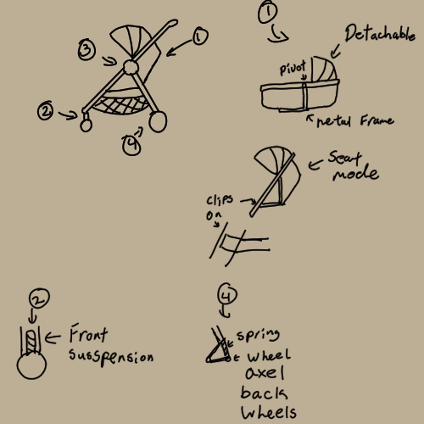

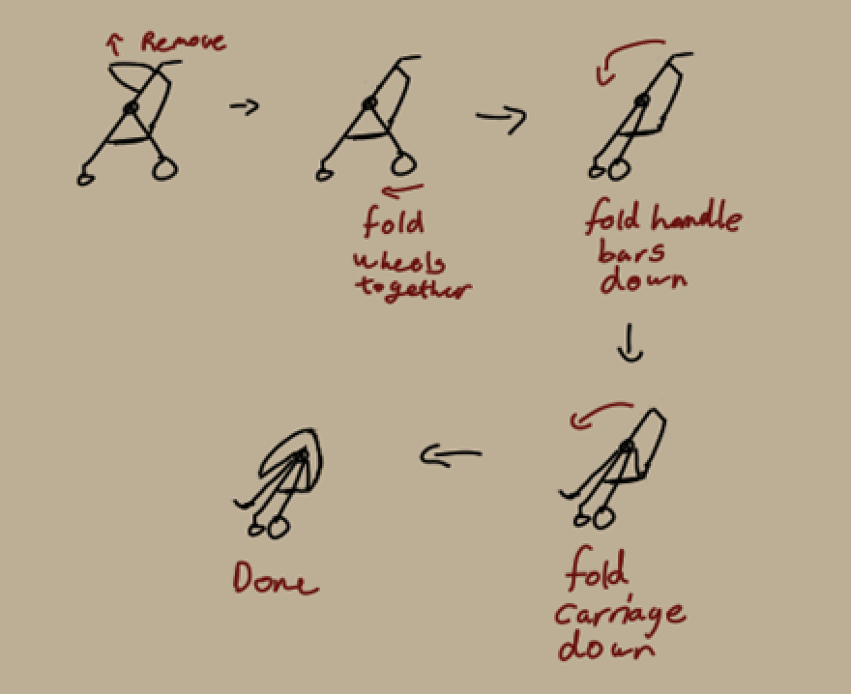

**Description:**

This design concept is for a transforming stroller that allows for a variety of age ranges to utilize whilst not compromising on storability. A main feature of this design is the convertible stroller carriage that transforms from a baby carriage to a stroller seat. A metal frame runs underneath and to the side of the carriage providing excess support and stability. When the user wants to turn the carriage into a seat, simply rotate along the pivot and lock the pivot in place. The excess fabric can then be folded away and held back using velcro.

The storability of the stroller was another issue that was present as a stroller is quite large and space attentive. As a result, this design aims to solve that problem by having a single large pivot that allows the entire stroller to fold about this point. This allows for a simpler process of collapsing the stroller and allowing the stroller to fold flat.

Comfort whilst a passenger is in the stroller was also a concern whilst designing this as the purpose of this stroller was to allow for it to be used in many different terrain. As a result suspension was added to the wheels to help lessen any change in the terrain. In this design internal wheel suspensions were added in the front rotation collumb, which allows for the front wheels to rotate freely whilst dampening any bumps. The rear suspension is much simpler as the wheels are fixed, allowing to have the suspension be two separate parts held at a joint with a spring to act as the suspension.

The entire frame of the stroller is aluminum allowing it to be lightweight yet durable and corrosion resistant. Underneath the carriage will be a storage compartment made from polyester netting which is durable and water resistant. The carriage will be made from a mix of polyester and wool to allow for comfort and breathability, whilst the outside is water resistant.

**Usage scenario**

1. Setup
2. Place the stroller wheels down
3. Pull the wheels apart till they click in place
4. Unfold the stroller carriage till it clicks in place
5. Unfold the handle bars till it clicks in place
6. Adjust the carriage into the preferred mode
7. Attach carriage cover if desired
8. Use
9. Place passenger into the carriage
10. Secure the passenger
11. Adjust the cover as needed
12. Begin to push the stroller
13. Use the storage compartment when needed
14. Put away
15. Remove the passenger and ensure that there is nothing left in the carriage
16. Unlock the joint and begin to fold the wheels together
17. Then fold the handle bars over
18. Fold the carriage over and store away

| Demand Type | US Step # (Most demanding task) | Demand Level | Notes |
| --- | --- | --- | --- |
|  | **SET UP** |  |  |
| Perceptual | 1b/c/d | 2 | Use of touch and vision to ensure stroller is properly sacred |
| Cognitive | 1e/f | 3 | Familiarity with how the carriage conversion and sunroof work |
| Physical | 1a/b/c/d | 3 | Heavy lifting, and forceful manipulation is required with the help of two hands |
|  | **USE** |  |  |
| Perceptual | 2d | 3 | Good spatial awareness is required |
| Cognitive | 2d | 3 | Hand eye coordination is require as well as quick cognitive function |
| Physical | 2d | 2 | A strong force may be required to get the stroller moving depending on the weight of the contents |
|  | **PUT AWAY** |  |  |
| Perceptual | 3a | 3 | Ability to see whether or not it is safe to collapse the stroller |
| Cognitive | 3b | 2 | The ability to understand the step required to collapse the stroller properly is required |
| Physical | 3b/c/d | 3 | A reasonable amount of force will be required to collapse and store away the stroller |

# 

# 

# 

# 

# 

# 

# 

# 

# 

# 

# 

# Design issues

**Design Concept 1:**

* Step 2a: Seat position is not adequately locked in place while baby is being put in, could cause safety issues
* Step 2g: Swivel wheel in the near the center of the stroller causes front and back rocking

**Design Concept 2:**

* Step 2d: Stroller cannot be locked in place while user steps away, only temporary braking
* Step 2d: Braking requires a lot of grip strength which could be lacking with elderly users
* Step 2a: When placing the child, there is not an option for any shade or sun protection

**Design Concept 3:**

* Step 2c: The braking mechanism becomes worn from use and doesn’t function properly
* Step 2f: The fifth wheel mechanism may wear over time and won't function properly

**Design Concept 4:**

* Step 2e: Handlebars at 90 degree angle to horizontal could be uncomfortable to user
* Step 2a: Surrounds of crib being rigid rectangular material causes discomfort to arms when placing baby
* Step 2a: Edge of seat causes discomfort to child’s legs due to sharp corner with no flexible material

**Design Concept 5:**

* Step 1.5: One handed folding method may cause pinching if not careful
* Step 2.1: Too much strain on main pivot point, causes wear

**Design Concept 6:**

* Step 1e: Adjustment of the seat may cause pinching
* Step 1b: Main joint will wear over time and the locking mechanism may break over time

# references

[1] [Situational Knowledge Base](https://docs.google.com/document/u/4/d/1YEjEXJfWXH6WhaKF20ACS39N4-rEMIp-a03EXtmuQ7s/edit)

[2] [Product Requirements Specification](https://docs.google.com/document/u/4/d/1LMugEXPa0HnsH9wpF-9OzrFE8Vx3RFWa1lHnymmNr1Q/edit)

[3] [Product Design Specification](https://docs.google.com/document/u/4/d/19KGi0PIx9DB-yrT7nRob-Qy8iMO80u0HPKYj3moV8S4/edit)

1. Only the last 5 digits of the student number are required.